Measuring the Impacts of COVID-19 Pandemic on Public Transit Demand in US

Luyu Liu

COVID-19 decimated transit systems’ ridership. However, the specific impact is still largely unknown. In this paper, we use transit demand data collected from Transit app to measure the impacts of COVID-19 in different dimensions. We use logistic model to fit daily transit demand data and introduce three key parameters to measure the three dimensions of the transit recession: *floor value*, which represents the extent of decline and ratio of “essential passengers” who still use the transit during the pandemic; *decay rate*, which represents the speed of the decline; and *divergent and convergent point*, which represent the beginning and end day of the decline process. The regression shows that higher transit usage rate is linked with lower non-physical employed population ratio, more minority population (African American, female, Hispanic), higher ratio of people over 45 years old, and lower Google search index. We demonstrate that the majority of the transit systems have not finished declining when the local community spread started. Hourly analyses show the pandemic had significant impacts on the transit commute beyond the average usage decline, making weekends and weekdays more alike each other. Morning rush hours shifted differently for cities but afternoon hours generally shifted later. This paper is the first effort to reveal and quantify the impact of the unprecedented pandemic and the conclusions are necessary and important for future transit planning and administration.

Keywords: COVID-19; public transit; essential workers.

1. Introduction

A novel coronavirus disease (COVID-19) has evolved into a global health crisis for its high contagiousness, high fatality rate, and lack of known treatments. To deal with the pandemic, Centers for Disease Control and Prevention (CDCs) and governments in different places recommended social distancing, self-quarantine, and work from home policies to stop the spread of the virus. However, the sudden shutdown also caused recessions in the domain of mobility, economic, and social activities. Different modes of transportation, especially mass transit, suffered considerable loss of passengers due to self-quarantine recommendation and contagion concerns.

This sudden meltdown especially impacted the public transit system across the United States compared with other modes. First, just like other transportation modes, fewer passengers need to take the transit systems due to the suspension of all unessential businesses and work-from-home orders. Moreover, compared with other transportation modes, public transit systems are perceived to have higher risk. It is natural and common to assume that sharing a narrow and unventilated space with numerous strangers is a bad idea during the pandemic, thus people will generally avoid taking transit trips. According to an online survey (sample of n = 1000 Americans and n = 1000 Canadians), about 48% of Americans and 40% of Canadians feel that riding transit poses a high health risk due to the virus (2). Therefore, almost all transit systems has witnessed some degrees of transit demand decline even before the outbreak of the pandemic. For larger transit systems, for example, Washington Metropolitan Area Transit Authority reported that metrorail ridership has been reduced by 90% and bus ridership has been reduced by up to 75% by the end of March (3); for smaller transit system such as El Dorado transit in El Dorado county, California, the ridership also decreased by up to 75% (4). This unprecedented widespread recession has created major economic and stuff health difficulties for all public transit systems across the nation. It is necessary and urgent to measure the impact of the COVID-19 pandemic on the transit systems in different dimensions.

Although it is the first time for the last 30 years that the US society witnesses a total lockdown at the nationwide scale due to a pandemic, there are still sources and experiences about how a pandemic could impact transit systems in different contexts. For example, the severe acute respiratory syndrome (SARS) outbreak in East Asia in 2003 and the Middle East respiratory syndrome (MERS) outbreak in Korea in 2015 all had major impacts on local transit systems in different extent and speed. Wang (2014) used a statistic model to measure the fear of the 2003 SARS pandemic by the ridership decrease of Taipei underground system in the city of Taipei, Taiwan. Based on ridership data from 2001 – 2005, the paper reported that the pandemic resulted in an immediate loss of 1200 ridership per day and 50% of daily ridership compared with ordinary days during the peak of the SARS pandemic. The paper concentrated on the modelling of fear: the total fear is decomposed into the fresh fear, which is generated by the increasing daily confirmed patient’s number, and the residual fear, which propagated and exponentially decays to the following days. Kim et al. (2017) also addressed the fear exposure during the 2015 MERS outbreak in Seoul, South Korea with the transit system smart card transaction data. The paper discussed the variation of trip frequency for different public transit mode, different populations, and different traffic analysis zone in Seoul. The paper also pointed out that fear towards the pandemic had a significant influence on travel behavior; people’s ability to change their daily routine, which is measured by land value in the paper, is relevant when determining the extent of behavioral change. However, the focus of these papers is not transit system per se, but the fear exposure; therefore, the papers did not cover the process of transit ridership recession and its implication. Meanwhile, though the microscope analyses are extremely useful, these results may not apply in other contexts; their special demographic and social-economic status also makes the results exclusive for the East Asia cities. Therefore, it is necessary and urgent to address the impacts of COVID-19 pandemic on the US transit ridership with new measurements and new data; this includes the impacts’ extent, geographic and temporal variation, and its relevance with the development of the pandemic.

In this paper, we use the transit demand decrease data obtained from a popular mobile transit planning app, Transit app, and conduct comprehensive analyses in different dimensions to measure COVID-19’s impact on the transit systems and their passengers. We use logistic model to fit daily transit demand decrease and get three key parameters from the models which correspondingly represent three dimensions of the recession: floor value, which represents the extent of the recession; decay rate and decay duration, which represents the speed of the recession; divergent and convergent point, which represents the initial date and last date when the transit demand began and finished to decrease. We moreover conduct regression and correlation analyses between floor value/decay rate and different social-economic and demographic factors. We also compare the distance between the divergent/convergent point and the first date of local community spread to measure whether passengers in different metro areas acted faster than the local pandemic evolution. We moreover use hourly transit demand data to capture COVID-19’s impact on transit commuting; we assess the similarity of hourly curves’ shape with ordinary Procrustes analysis and compute the shift of morning and afternoon rush hours. In the end, we conclude several important insights we can gain from the results and propose several future directions for transit studies in the context of COVID-19.

1. Data and methods

In this section, we first introduce our data sources of the transit demand and COVID-19 daily cases statistics. Then, we introduce our theory about the dynamics of transit demand, three key parameters in the model, and their correlation with different social-economic factors and the evolution of the pandemic.

* 1. Data sources

**Transit demand change.** We collected the daily and hourly transit demand change data via the web interface maintained by Transit app. Transit is a popular mobile app providing real-time public transit data and trip planning. The app covers over 200 cities around the world with more than 5 million download on Android platform (7). Therefore, although the actual ridership data is still largely unknown and inaccessible, the usage of the app can be regarded as a rough measure for the transit demand of these app users (8). As COVID-19 hit the world and the transit demand decreased consequently, the app website kept updating on the changes of transit demand on an everyday basis. The change values are a set of percentage, calculated by comparing actual usage of the app to projected use of the app based on last year’s numbers. The projected numbers are also adjusted for annual growth (8). By this adjustment, the values can represent the difference between expected and the actual transit demand.

To valid the authenticity of transit app data, we collected the official ridership decrease report from each system’s website and local news. However, most transit system will not release the full data for each date, instead, many will only release one estimate for one certain day. We collected the reported ridership decrease percent and report date and compared them with the corresponding demand decrease percent from the Transit app dataset in the same date. Figure 1 shows the proximity between the two measures for 40 transit systems that we could trace the actual ridership decrease value. Then we computed the difference of the two measures as the bias for Transit app demand decrease; we moreover calculated the difference’s average value and standard deviation. The average bias is 3.7% and the paired T-test shows that p-value is 0.14>0.05; this means we cannot reject the null hypothesis of no difference between two means, suggesting the conditional unbiasedness for the sampled 40 transit systems. The standard deviation is 15.96%, which may be because of the different definitions of normal ridership level. Generally speaking, the comparison shows that the transit app demand data can be a good indicator despite non-trivial standard deviation.

Although the small-sampled test shows the unbiasedness of the Transit app data, the difference between the behaviors of apps users and other users, the accurate ratio of apps users among all transit users, and other factors affecting the representativeness of the usage statistics are still largely unknown. However, we can still use it as a rough but reasonable proxy to capture the changes of transit demand and ridership caused by the COVID-19 pandemic due to the large user group and popularity of real-time transit apps.

Figure 1: the proximity between actual ridership decrease and demand decrease for 40 transit systems.

The daily data includes demand decrease for 182 public transit systems across the United States, Canada, Australia, New Zealand, and France. We select 113 county-level transit systems in 63 metro areas, 52 counties, and 28 states across the United States. We exclude 7 state-level or cross-counties systems for their ridership could come from very diverse areas, such as Pacific Surfliner, which extended to the whole South California coast and Metro-North Railroad, which crosses multiple counties and states. We also use hourly demand decrease for 93 public transit systems across the United States.

**COVID-19 case numbers.** We collected the daily case numbers for each county from the COVID-19 Surveillance Dashboard produced by University of Virginia (9), COVID-19 Dashboard produced by John Hopkins University (10), and COVID-19 maps and county-level dataset produced by USAFacts (11). The data includes all counties’ confirmed cases in the US for every day. To find the linkage between the case numbers and the demand decrease, we geocoded each transit system to the corresponding county or county equivalent unit.

* 1. **Logistic model for daily transit demand change.**

For all systems during the first few days, the demand generally oscillate around the base line. As the epidemic and quarantines progressed, the demand gradually decreased, until reached a very low level and then stabilized. Such a shape of the curves can be well fit by a logistic function; a logistic or sigmoid function can be expressed into the following form:

|  |  |  |
| --- | --- | --- |
|  | $$f\left(x\right)= \frac{B}{1+e^{-k(t-t_{0})}}+b$$ | (1) |

Where: $B$ is the curves’ minimum decreased value, $b$ is the curves’ baseline value, k is the logistic growth rate or steepness of the curve; t represent the time (day) and $t_{0}$ is the day when the function reaches the midpoint. We will fit each transit system’s demand data using logistic model individually and calculate these three parameters. The three parameters, B, k, and L, represent three aspects of the transit demand decline process:

**Floor value: the extent.** In the logistic model, the parameter B represents how far the curve can decrease from the baseline. The curve decreases rapidly and then stabilizes around the B value, therefore we name it *floor value.* In the practical sense, it represents the ratio of public transit users in the system that still would not or cannot stop needing it regardless of the pandemic.

To test its potential linkages with different social-economic factors, we conducted linear regression analysis between different transit systems’ floor values and the social-economic factors of the corresponding county-equivalent. The county-level social-economic data are collected from the latest American Community Survey (ACS) 5-year estimate table (2014 - 2018). We select several potentially relevant indicators:

* Ratio of population with non-physical occupations.

Similar to *life fixity* introduced by Kim et al. (2017), the ratio of population with non-physical occupations measures the population’s degree of freedom to change the routine of their daily life. It represents how many people can work from home thus avoid regular transit commuting to reduce contagion risk. If an area has higher ratio of non-physical jobs, more workers may supposedly work from home thus the transit demand will decrease further.

We used the occupations statistics for employed civilian population 16 years and over from the ACS data. The table contains the number of employed population in different industries. According to the statistics released by US Bureau of Labor Statistics, Information, Financial activities, and professional and business service have the highest percent who can work from home (12,13). Therefore, among these occupation categories in the ACS table, we assign “management, business, and financial operations occupations”, “professional and related occupations”, and “office and administrative support occupations” as the occupations with which people can work from home remotely.

Income is another major social-economic indicator that has natural connection with job composition. We used the median income data from ACS.

* Ratio of minority population: African American, female, and Hispanic population.

Many studies has demonstrated the disadvantaged status of African American, female, and Hispanic population in mobility and job accessibility across different metro areas in the United States (14–16). Therefore, it is necessary to investigate the relationship between floor value and each vulnerable group’s ratio. We also collected the last sex, race, and Hispanic population data from the ACS data.

* Age structure.

COVID-19 is highly sensitive to different age groups. According to the New York City health report as of April 28th 2020, the death toll for people over 45 years old accounted for 96% of total death toll in the New York City while people over 65 years old accounted for 77% of total death toll. As of April 28th 2020, people over 45 years old accounted for 97% and people over 65 years old accounted for 79% of total deaths reported to the National Center for Health Statistics (17). Therefore, based on these statistics, 45 years old as a stricter threshold is a good standard to identify the high-risk population. We collected the ratio of people with age over 45 from the ACS 5-year estimates (2014 - 2018) data.

* Awareness.

If local residents are more aware of the COVID-19 and its risk, the floor value will be supposedly lower because more people will try to avoid public transit trips. To validate this, we choose Google search trend index to represent the awareness of the local people. Searching on the search engine, such as Google.com, has become one of the most common practice for people to acquire knowledge and information nowadays. Furthermore, unlike other social media platforms such as YouTube or Twitter, Google search engine does not have a recommendation system, which means users will mostly search actively based on their need and concerns. Based on these facts, many studies utilized the social media and search engine statistics to retrospectively evaluate or predict the relationship between the trends and the actual confirmed cases (18–20).

To validate the linkages, we collected the average Google search trend data for different designated market area that each transit system locates in for 90 days from January 18th to April 17th 2020 (21), which is the latest day we witnessed a system having a decline. We select “Coronavirus” over “COVID19” as the search keyword for two reasons: first, COVID19 as a newly coined word was not familiar to the public, since the official name was not introduce until February 11th; second, “Coronavirus” was more used by the media and the public in February and March and it has significantly higher search frequency than “COVID19”.

To moreover validate and supplement the correlation results, we also refer to the user survey results conducted by Transit app about the demography of the passengers during the pandemic. The survey was conducted in early April, 2020 across the United States (n = 15000) and Canada (n = 10000) via the Transit app interface. The survey investigated the age, race (including Spanish speakers), gender, trip purpose, occupation composition of the passengers who stick to transit systems during the pandemic (8,23,24). The user surveys provide first-hand proofs about the demography of the essential passengers and are a very good complement to the correlation conclusions.

**Divergent point and convergent point: the start and end.** The decline process mainly happens during a relatively short period in the middle. Therefore, to measure when the demand started to decrease and finally finished the decreasing process, we introduce two measures: divergent point $t_{d}$ and convergent point $t_{c}$. We apply the confidence interval theory to the definition of the measures by first construct the probability density function of the normalized logistic function F(x):

|  |  |  |
| --- | --- | --- |
|  | $$∀-∞<t<∞,F\left(t\right)=\frac{ f\left(t\right)-b}{B}=\int_{-∞}^{t}{P(t)dx}$$ | (2) |
|  | Then: $P\left(t>t_{c}\right)=1-\frac{f\left(t_{c}\right)-b}{B}= \frac{α}{2}$, and $P\left(t<t_{d}\right)=\frac{f\left(t_{d}\right)-b}{B}=\frac{α}{2}$ | (3) |

Where: P is the probability density function of the normalized logistic function; to normalize the logistic function, we subtract the baseline and divide the result by B to construct the P function so that $\int_{-∞}^{∞}{P\left(t\right)=1}$. $α$ is the confidence level. We choose 5% for the confidence level, which is a widely accepted value. The significant level is a useful threshold to decide whether a fitted value changes significantly compared to the baseline value/floor value.

From the formula (2) and (3), we can induct that $P\left(t_{d}<t<t_{c}\right)=f\left(t_{c}\right)-f(t_{d})=1-α$, which means under the confidence level of 0.95, we can make sure most change happen between the divergent point and convergent point. From the formula, we give the direct definition of divergent and convergent point:

|  |  |  |
| --- | --- | --- |
|  | $t_{d}=t_{0}-\frac{\ln\left(\frac{2}{α}-1\right)}{k}$ and $t_{c}=t_{0}+\frac{ln⁡(\frac{2}{α}-1)}{k}$ | (4) |

Moreover, the two measures are not directly calculated from the raw observed data, instead, we obtain the measures from the smoothened curve to remove the stochastic noise. They can be a stable indicator to measure the start and end of the demand decrease.

Beyond its statistical meaning, divergent point represents the first daywhen the demand curve began to diverge from the normality. It also represents when the transit users start to act to avoid the transit trips. Convergent point, on the other hands, represents when the decline finally finishes. After the convergent point, the transit demand will persist at a stable level.

**Decay rate: the speed.** k represent how fast the demand curve decreases.Therefore, we name it *decay rate*. Decay rate can be an important indicator for the actual response speed of urban residents/public transit users to the pandemic. Although the decay rate works well, the rate value per se does not have any physical meaning. Instead, we would like to use a temporal indicator to represent the speed and duration of the decline. From the logistic model, $t_{0}$ represents the time/days from the day zero to the curve reaches the midpoint of the curve. It reflects two major temporal factors for the pandemic: the initial date of epidemic outbreak, which is measured by the divergent point, and the duration of decay. Therefore, we introduce decay duration:

|  |  |  |
| --- | --- | --- |
|  | $$λ=t_{c}-t_{d}=\frac{2⋅ln⁡(\frac{2}{α}-1)}{k}$$ | (5) |

Decay duration is only determined by the decay rate.

Similarly, we conduct linear regression analysis and correlation analyses between the decay rate and different social-economic factors, divergent point, and people’s awareness.

* 1. **Desynchronization between response and pandemic evolution**

The process of transit demand decrease is not synchronous with the evolution of the pandemic. The transit demand decline process is indicated by the *divergent point*; the evolution of pandemic can be indicated by the *first date of community spread*, when the first people caught the virus. The exact date of first community spread is extremely hard to catch, however, it can be approached by the first date of confirmed case.

The difference between the two processes indicates the transit users’ responses compared to the evolution of the pandemic. If the value is smaller than 0, it means most transit users are still using the transit systems as their usual routine; if the value is bigger than 0, it means the transit user community started to make a response prior to the confirmation of the local outbreak. Another similar but equally important metric is the difference between the convergent point and the date of first community spread/first confirmed case, which shows whether the user can mostly avoid the transit trips when the epidemic arrives.

However, the date of first confirmed case can be very different from the day when the community spread started. There are several factors that postponed the first case being confirmed. *Incubation period* is the most important factor that should be taken into consideration defined by: from the first moment that the patient was infected by the virus, no symptoms will be shown for several days. The median of incubation period is 5 days and can be as long as 14 days (25). Meanwhile, numerous studies have proven that the virus can spread asymptomatically (26–28). Therefore, the actual initial date when the virus began to spread in the local community can be traced back to 4 - 14 days ago. This lag can be even longer considering the lack of testing kits and slow response for the local authority (29,30). Therefore, it is necessary to consider this temporal lag ahead of the first confirmed date to more accurately capture the first date of local community spread. We introduce an *incubation lag* parameter in the measures; it measures the temporal delay factors beyond the first case confirmed, such as incubation period and testing delay. Here, we introduce the definition of *response interval* from divergent point and convergent point:

|  |  |  |
| --- | --- | --- |
|  | $$Δt_{d}=t_{fc}-l-t_{d}$$ $$Δt_{c}=t_{fc}-l-t_{c}$$ | (6) |

Where: $t_{fc}$ is the date of first confirmed case in the county of the transit system; l is the incubation lag; $t_{d}$ and $t_{c}$ are the divergent and convergent point. Positive response interval means that the transit users responded earlier than the epidemic spread; the larger the value is, the less risk the transit users are exposed to the virus. For the two versions, the divergent version focuses on the transit users’ awareness while the convergent version focuses on both the awareness and the response speed.

* 1. **Dynamics change within a day**

The analyses based on the average transit demand of each day shows the coarse-grained temporal variation of different cities; however, the results do not address the transit demand’s variation within each day. In this section, we analyze and interpret the similarity between the two curves under the normal circumstance without the impact of COVID-19 and the actual circumstance with the impact.

**Similarity of shape.** To conduct the similarity analyses, we use the hourly transit demand change data. Like the daily data, the hourly normal values are also calculated based on the historical data and adjusted with annual growth.

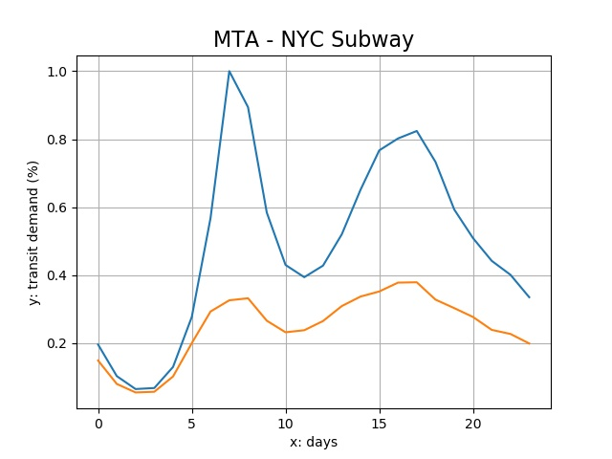

The similarity between the normal and actual curves can generally be decomposed into two factors: the average distance between the curve point and the difference between the shapes of curve point. We utilize an *ordinary Procrustes analysis* approach to measure the two factors. First, we will superimpose the curve of actual curve to the normal curve. For traditional Procrustes analysis for arbitrary shapes, the superimpose process includes panning, scaling, and rotating (31). However, because we know the shift of the demand curves does not contain the panning and rotating process, we will only conduct scaling process in practice. We use a stretch factor $p$ as a multiplier on the actual curve to fit the normal curve so that their Procrustes distance is minimized. The process can be denoted as:

|  |  |  |
| --- | --- | --- |
|  | Minimize: $$S(p)=\sqrt{\sum_{t=1}^{h}{{\left(p⋅f_{a}\left(t\right)-f_{n}\left(t\right)\right)}^{2}}}$$ | (7) |

Where: $S(p)$ is the Procrustes distance between the hourly curve before the pandemic and superimposed hourly curve during the pandemic, $p$ is the stretch factor, $h$ is the number of data points in the dataset, $f_{a}(t)$ is the transit demand during the pandemic at hour $t$, and $f_{n}(t)$ is the transit demand before the pandemic at time $t$. The solution to this optimization problem is:

|  |  |  |
| --- | --- | --- |
|  | $$p^{*}=\frac{\sum_{t=1}^{h}{f_{a}\left(t\right)⋅f_{n}(t)}}{\sum_{t=1}^{h}{f_{a}^{2}\left(t\right)}}$$ | (8) |

The optimal stretch factor $p^{*}$ can be regarded as a measure of average demand decrease, which can be a good complement to the daily transit demand decrease percentage data.

The Procrustes distance with the optimal stretch factor $S(p^{*})$ is a good measure of shape similarity without distance and size. It could reflect some very important aspects of the city’s transit mobility patterns, especially for commuting to work: for example, larger Procrustes distance means that the shape of current demand curve changes dramatically from the normal one; it also suggests that commuting decreases more than other transit activities during a day.

To moreover demonstrate the distinction between weekdays and weekends, we also calculate the Procrustes distance between the weekdays and the weekends:

|  |  |  |
| --- | --- | --- |
|  | Minimize: $$S'(p)=\sqrt{\sum_{t=1}^{h}{{\left(p⋅f_{e}\left(t\right)-f_{d}\left(t\right)\right)}^{2}}}$$ | (7) |

Where: $f_{d}(t)$ is the transit demand of a weekday at hour t and $f_{e}(t)$ is the transit demand of a weekend at hour t. Then we compare the distances before and during the pandemic. This difference of Procrustes distance can inform us that whether the distinction between weekdays and weekends changed by the pandemic.

**Peaks.** Peak analysis is crucial for the understanding of the mobility dynamics; it can provide demonstrate more detailed patterns for the shift of the curve shape, especially for commuting patterns. Peaks show the maximums in the curves of the hourly pattern in a day; their location and height can be a good measurement of commuting for transit users of the system. The comparison between before and during the pandemic can demonstrate the pandemic’s disruption on the commuting patterns and people’s adaptive behavior change.

Without the impact of COVID-19, most transit systems during weekdays will have two peaks within a day: the morning rush hour usually from 6 to 9 am, when most passengers commute from home to work places; and the afternoon rush hour usually from 4 – 7 pm, when most passenger commute from work places to home. However, this may not hold true after the outbreak of COVID-19. In practice, we first find all the peaks in the curve and find the two highest peaks before and after 12 am within a day, which are corresponded to the morning and the afternoon rush hour. The shifts of peaks, including numbers, position, and height, may vary according to each cities’ demographic and social-economic status.

1. Results and discussion

In this section, we will first show the geographic and temporal pattern of floor value, decay rate, divergent and convergent point. We will also show the regression and correlation results of floor value and decay rate with different social-economic factors. Then we demonstrate the response interval for each city and show their sensitivity with different possible incubation lag. Last, we shows the pattern of Procrustes distance and the rush hour shift.

* 1. Floor value and relevant factors

For different systems in different metro areas, the floor value is vastly different due to their different social and economic status as shown in Figure 2. It shows a clear North-South and East-West rivalry: cities in the Deep South and Midwest generally have higher floor value. Meanwhile, information industry-dominating area such as San Francisco Bay area and university cities such as Ithaca, Ann Arbor, and Madison generally have a very low floor value.

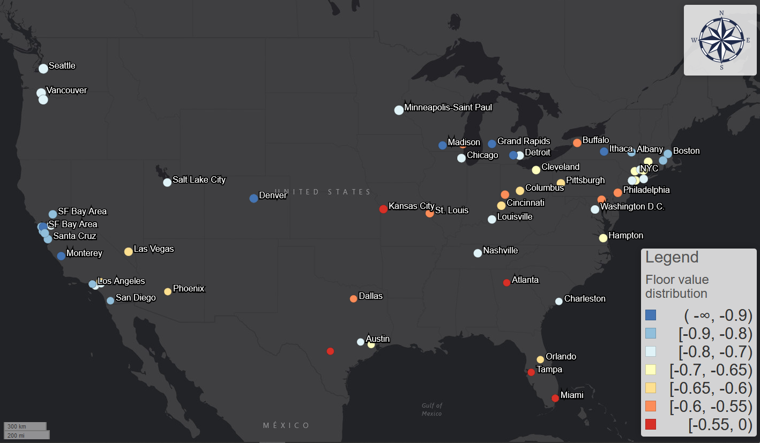

Figure 2: The distribution of floor value across the United States.

The regression results between the floor value and each factor in Table 1 shows that four factor are significant with p-value smaller than 0.05; the F test also shows the model is significant with p-value of 1.41e-10. The R-squared value is 0.38, which indicates relatively large effect size. The residuals assessment moreover shows that the residuals are subject to normal distribution and there are no multicollinearity effect and no leverage points.

|  |  |  |  |  |  |  |
| --- | --- | --- | --- | --- | --- | --- |
|  | Estimate coefficient | Standard Error | t value | Pr(>|t|) | VIF | R-squared increment |
| Intercept | -0.52997 | 0.169042 | -3.135 | 0.00221 | - | - |
| Ratio of people with non-physical occupation | -0.4269 | 0.129248 | -3.303 | 0.0013 | 1.21 | 0.063 |
| Ratio of African American population | 0.412221 | 0.075941 | 5.428 | 3.53E-07 | 1.08 | 0.17 |
| Ratio of population over 45 years old | 0.856343 | 0.264103 | 3.242 | 0.00158 | 1.05 | 0.061 |
| Google search trend index | -0.00502 | 0.00197 | -2.55 | 0.01217 | 1.21 | 0.037 |

Table 1: regression results

**Ratio of population with non-physical occupations**.

The results validate the previous claim: more transit demand decreases and higher percentage of people with non-physical occupations are correlated. The lockdown resembles a sieve: only the most essential, the most resilient, and the most desperate would stay.

Meanwhile, Hispanic population ratio can also be a significant factor when added to the regression model. However, we do not directly add it to avoid multicollinearity, since the further correlation analyses between Hispanic population ratio and non-physical occupation ratio indicate very strong positive correlation. This correlation moreover suggests the vulnerable of Hispanic population during this health crisis: if a city has more Hispanic population, it is very likely for the city to have a high floor value, which means more people will not work from home during the pandemic. This is also consistent with the occupation statistics: according to the labor force characteristics survey made by US Bureau of Labor Statistics, Hispanic population has the lowest percent (22%) of management, professional, and related occupation compared with White (41%), African American (31%), and Asian people (54%) in 2018 (32).

The ratio of people with non-physical occupations is also correlated with the median of income. In our correlation analyses, if the transit is located in an area with higher income, the floor value of the transit demand is also likely to be lower. The income has a natural linkage with the occupation composition.

These results are also proven by the user surveys conducted by Transit app in April 2020. According to the survey results, 92% of all the surveyed users reported that they still use public transit to commute to work (23). Meanwhile, the top-5 occupation categories that are most likely to work from home are computer and mathematical; life, physical and social science; education, training and library; architecture and engineering; and legal. Although the categorizations of the survey and the ACS table are different, this is generally consistent with the non-physical occupation categories we assumed in the ACS table.

Moreover, the survey also proves that Spanish speakers are more likely to continue using the Transit app for trip planning purposes: English-language users dropped 71% from early February while Spanish-language users dropped by 50% over the same time period (24). The income correlation is also confirmed by the survey results: compared with the survey results conducted by American Public Transportation Association (APTA) in 2017, active users skew towards lower income brackets during the pandemic, especially for those whose annual income is less than $15000 (24). The survey results provide a first-hand proof and reaffirm the correlation results about the vulnerability of Hispanic population and low-income population.

**Age.** Meanwhile, there is a correlation between the more senior population over 45 years old and higher floor value. This is ironic and alarming: senior people are the most vulnerable population while the area with more these people generally will have higher floor value.

This is also proven by the user survey. By comparing the users age composition survey conducted in September 2019 and April 2020, young people under 18 and between 25 to 44 years old tend to stay in quarantine across the US; meanwhile, the relative ratio of people between 45 to 64 years old has doubled (24).

**African American.** The regression analyses also suggest the vulnerability of African American population. It turns out to be the most significant factors among all the other factors from the R-squared increments in Table 1. There is a strong correlation between higher ratio of African American population and higher floor value.

These results are also consistent with the results of the user survey. During the pandemic, African American people have the greatest share (>35%) of riders compared with other races in the US, while Caucasian were the majority (>40%) of the rider before the pandemic according to the APTA survey in 2017 (23). The disproportionate decrease of African American population’s transit demand supports the conclusion that cities with more African American population are more likely to have a higher floor value.

**Female**. Higher floor value is highly correlated with larger ratio of female population, however, we also do not directly add it due to multicollinearity with African American population ratio. Higher ratio of female population is also correlated with lower income and lower ratio of people with non-physical occupations. These results indicates the disadvantage of female population in different social-economic aspects.

The user survey results also demonstrate astounding evidences that support the correlation analyses. Among all the US users surveyed, 56% are female while only 40% are male; while the gender ratio is 49% to 49% before COVID-19 pandemic (23). For some cities such as Philadelphia, more than 68% of riders are women. Meanwhile, Transit app users of color are also more likely to be females; more than 70% of the black riders are female during the pandemic (23).

**Awareness.** Google search trend index is significantly correlated with the floor value; cities with higher search index tend to have lower floor value, as higher search index means COVID19 has higher ratio among all the things they search. This indicates some effects of people’s awareness on their behaviors: with people cares more or more people care about the evolution and risk of the disease, more people will try to follow the stay-at-home order and avoid unessential public transit trips. However, according to the R-squared increase table in Table 1, Google search trend index has the lowest R-squared increase. It shows that people’s race, job, and age composition outweigh the awareness or preference when it comes to whether people will stay at home.

Floor value is a good measure to demonstrate the potential of transit demand and who the “essential workers” are. The regression analysis and the survey results show its inherent linkages with different aspects of the social-economic factors. It also illustrates a dark and cruel insight: the usage of transit during the pandemic is primarily correlated with minority and vulnerable populations who have less medical resources to resist the pandemic, and this usage is less correlated with people’s awareness.

The values and distribution of floor value also indicates the resilience and the necessity of the transit systems. The fact that most floor value still maintained a relatively high value for a long time demonstrates that people did and will still need transit system during the pandemic, and disproportionate amount of these “essential passengers” are minority and vulnerable population. Transit systems, as a semi-business to pursue ridership for more revenue, are clearly more than just business. As underprivileged and vulnerable population depend on them, it is time to rethink the role of transit system in future and invest transit as a necessary social welfare. This is going to be more urgent in the COVID era and subsequent post-COVID era than ever.

* 1. **Desynchronization between demand decrease and epidemic.**

Figure 5 shows the distribution of the response interval measures in the US from both divergent and convergent point for incubation lag = 0, 5, 14 days. Figure 6 shows the impact of incubation lag on the ratio of transit systems with positive response intervals (earlier response).

For response intervals from the divergent point: when not considering the incubation lag, the pattern is highly polarized. In some cities with international airports, such as Seattle, Washington State where the first US COVID-19 cases were found, people still used the transit even after the first case emerges. Meanwhile in other cities, such as most cities in Middle West except Chicago, although the cases have not been found in these cities, people already started to avoid transit trips. This can be because the media began to report the severity of this disease and CDC made the prediction that the community spread is inevitable near the end of February 2020 (33).

However, after we consider the incubation lag = 5 days, which is the reported median incubation period, many areas with earlier response now have negative response interval. A most noticeable area is the New York City. With lag = 0, out of 13 transit system in the New York City, there are 5 systems that have positive response intervals, such as MTA - Bronx buses, Suffolk County Transit, and Long Island Rail Road; when lag = 5, all of the 13 transit systems all have negative response intervals. This also suggests that New York transit users did not realize the necessity of avoid transit and non-essential trips when the community spread began. On the contrary, most transit systems in the Middle West such as Missouri, Ohio, Michigan, and Kentucky still have positive response intervals. This phenomenon is also supported by the cellphone location data: those places mentioned above had known stay-at-home orders before March 27th and the measured trips are significantly less (34). Due to earlier response, the transit users in these area may be exposed to less risk during the pandemic. However, for the scenario of lag = 14 days, which is a highly hypothesized scenario, most transit systems and most cities have negative response.

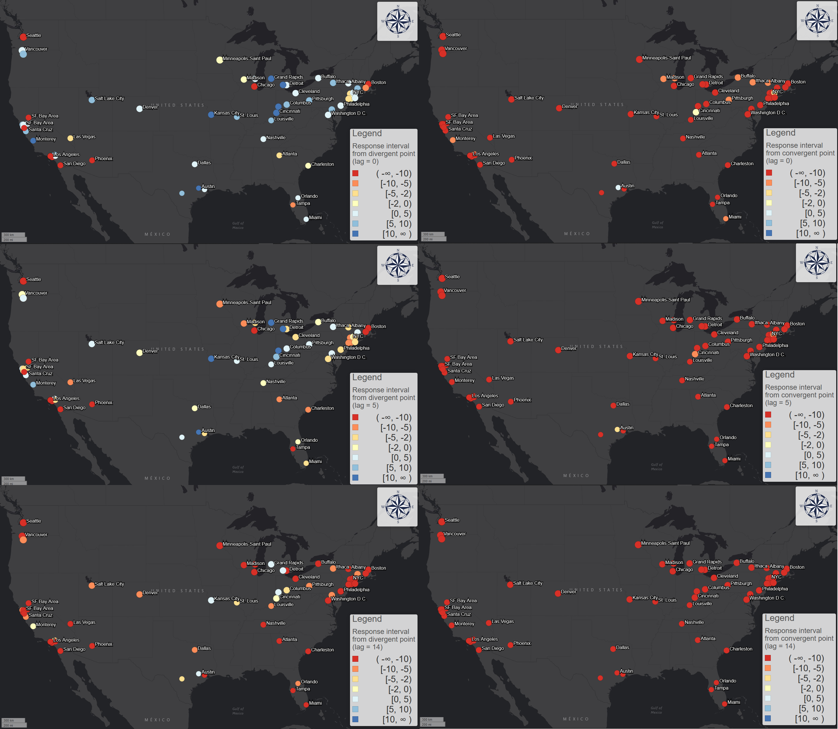

Figure 3: the geographic pattern of response interval with incubation lag = 0, 5, and 14 days for both from divergent and convergent point.

However, the geographic pattern is highly homogeneous for the response intervals from convergent point, which represent how earlier is each transit system’s users finished the stay-at-home process compared to the community spread. For scenario of lag = 0, only Capital Metro in Austin, Texas and HRT in Hampton, Virginia have positive response interval. For the case of Austin, the demand decrease started at March 6th and finished at March 22nd; the first case was confirmed at March 25th. However, long before the first confirmed case, the city and county authority declared the local state of emergency in March 6th (35), which is one of the earliest places to take actions in the South, even in the United States. The divergent point is also the same as the date of local state of emergency, which suggests the effectiveness of the executive order. This can be one reason for the relatively fast and earlier reaction of transit users.

Under the most ideal circumstances, the curve should already finish the declining process before the community spread, which means most transit users can avoid non-essential transit trips after the virus began the local spread. However, for larger lag such as lag = 5 and 14 days, no transit systems and cities have positive response intervals. This suggest that all mentioned US transit systems have not completed the decreasing process when the community spread has started.

Figure 4: Trend of the ratio of transit system with positive response interval for different incubation lag

* 1. **Decay duration**

Figure 5 visualizes the geographic pattern of decay duration. According to the correlation analysis, the decay rate and the divergent point have a positive cubic correlation as shown in Figure 6. This relationship indicates that the later the demand decrease happened, the faster it is likely to be and it increases in cubic rate. This could be because the general transit passengers may be more aware of the risk of COVID-19 when more cases are reported nationally; the perceived fear grows higher as the time passed thus driving local population to act faster.

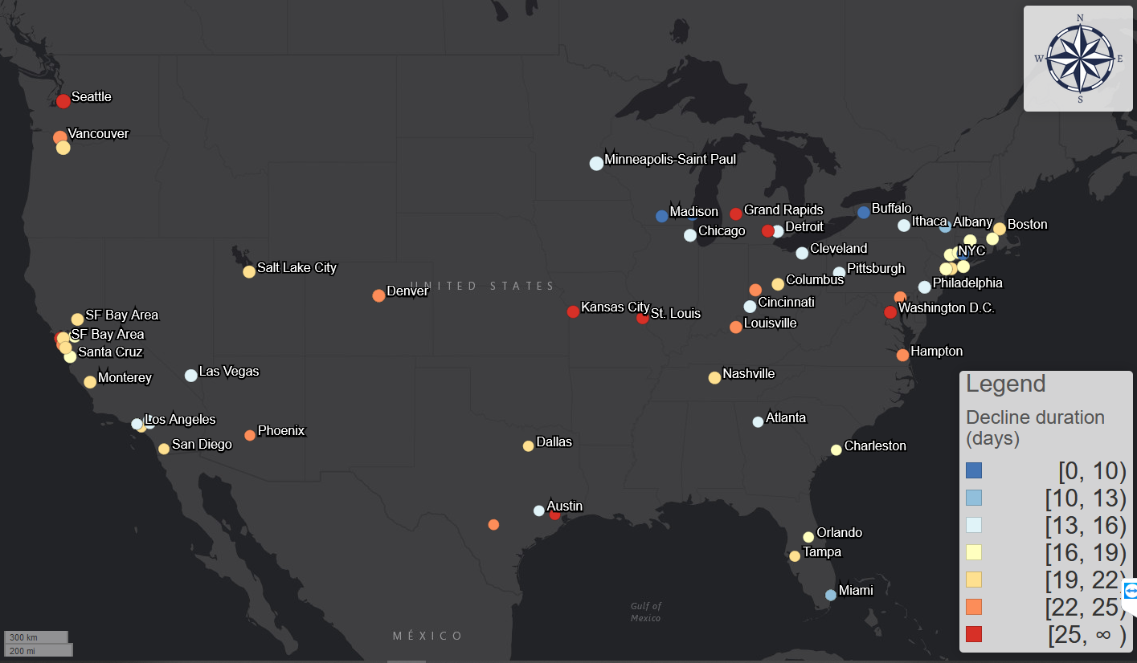

Figure 5: the distribution of decay duration

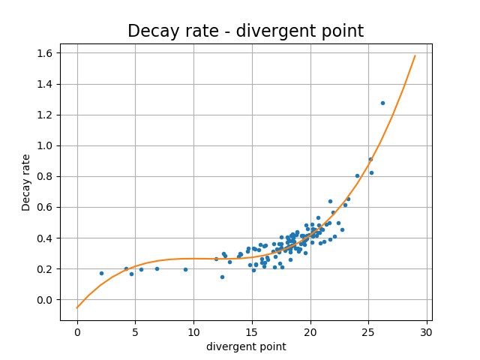

Figure 6: the relationship and a cubic polynomial fitting between decay rate and divergent point.

* 1. Dynamics within a day

Figure 7 shows the geographic distribution of each transit system’s average Procrustes distance between its normal and actual hourly demand curves. It shows a very different pattern for traditional metro areas like New York City and non-physical occupation dominating areas like San Francisco Bay area, and University cities like Ithaca, Madison, and Ann Arbor. The Procrustes distance of traditional metro areas is low, meaning the shape before and during the pandemic did not change much; while the large distance of non-physical occupation dominating areas suggests a major change in their commuting patterns, for most workers will work from home thus most commuting activities will be halted. This is highly similar to the pattern of floor value. Figure 7 also indicates the strong correlation between the two measures. This also suggests that cities with lower floor value tends to have more uneven and disproportional change within a day.

Figure 7: Relationship between average Procrustes distance and floor value.

Figure 8 (left) shows the temporal distribution of all the transit systems’ average Procrustes distance between its normal and actual hourly demand curves. The distance between current and expected demand steadily increased, which means the shape of the current demand is gradually diverging from the normal shapes, and then stabilize.

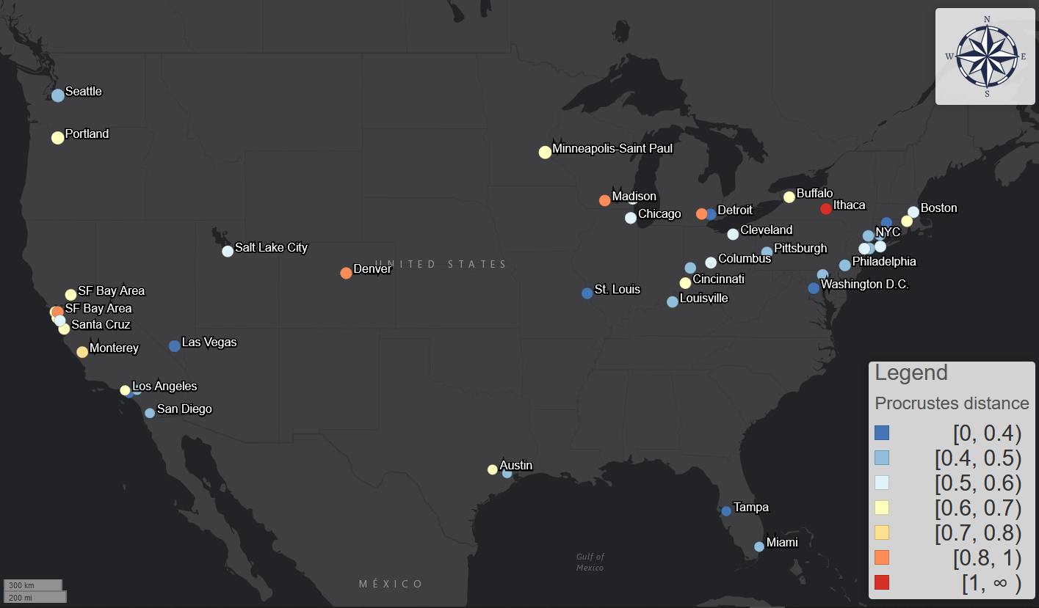

Figure 8: geographic distribution of each transit system's average Procrustes distance between normal and pandemic curves.

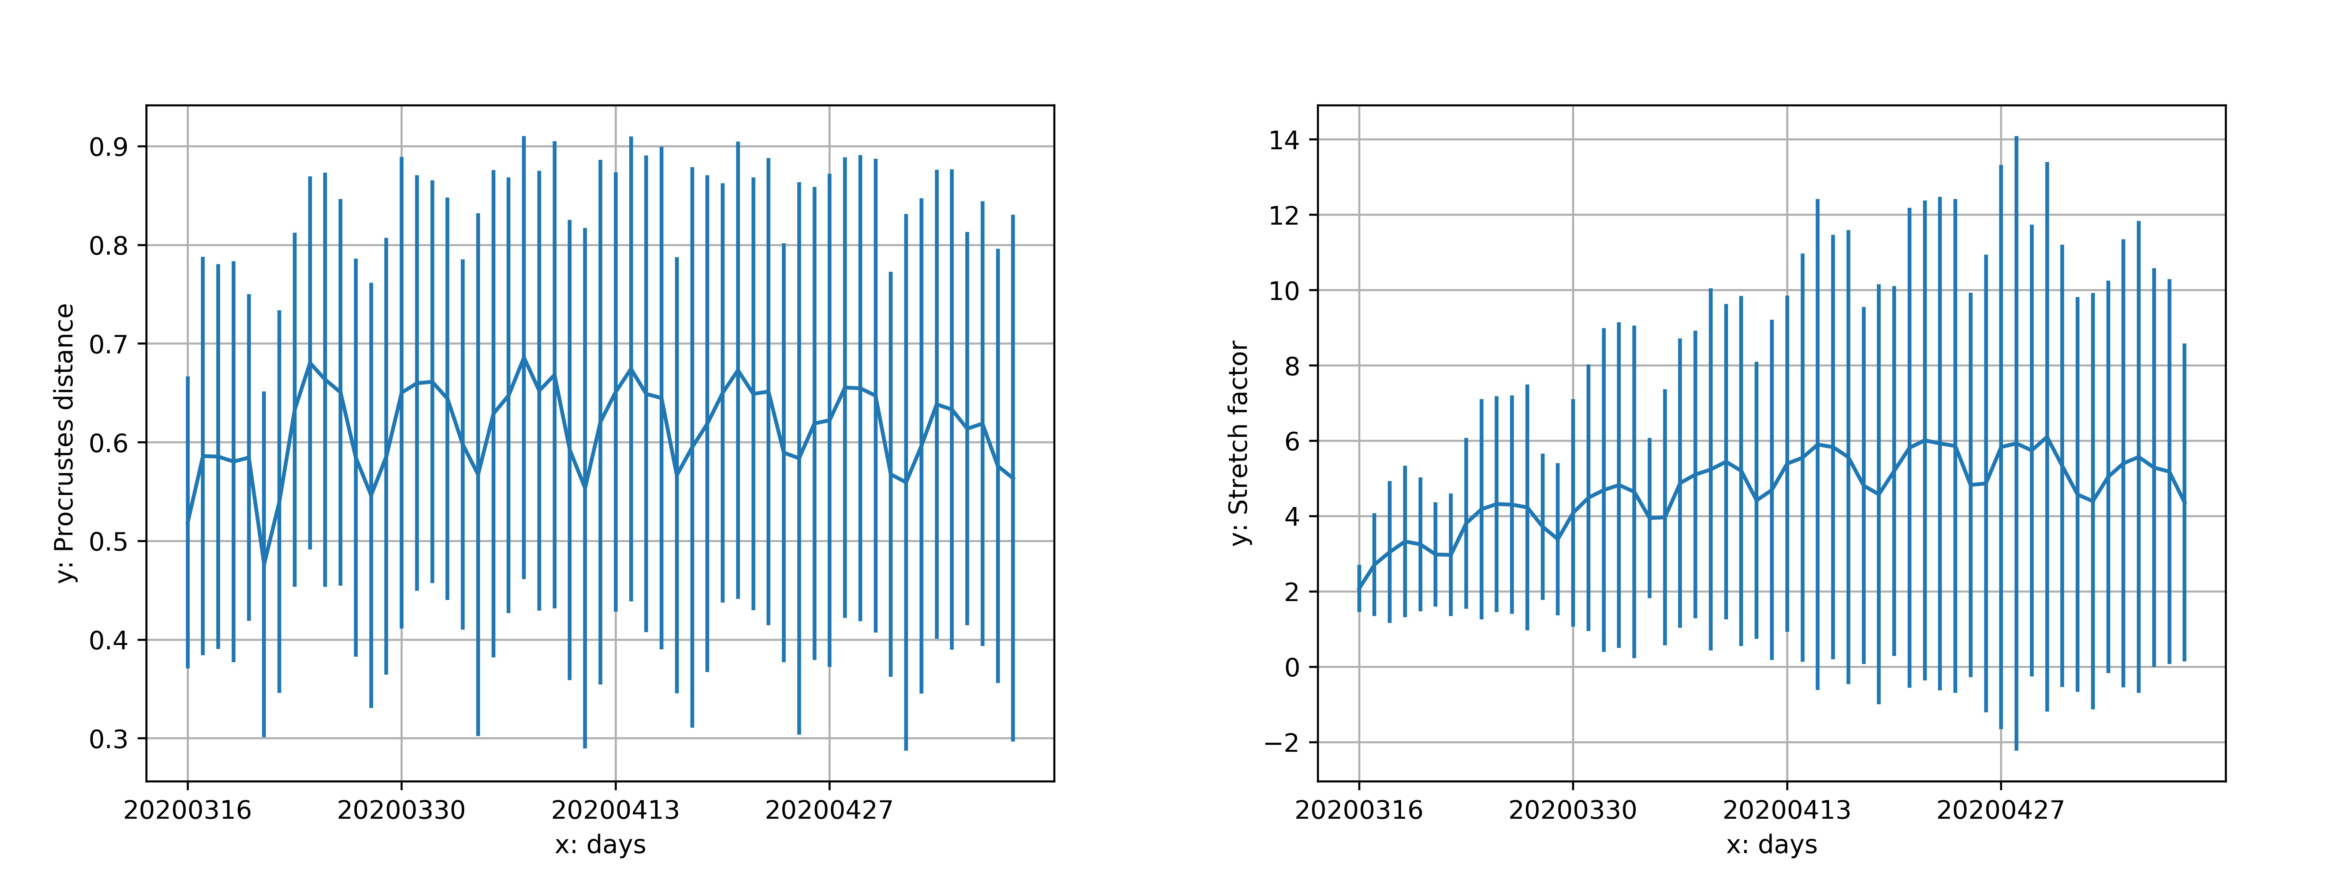

Figure 9: temporal distribution of all transit system's average Procrustes distance and stretch factor between normal and pandemic curves.

The shape of the distance value also shows a very regular periodical pattern for each week and the distance is much higher for weekdays than weekends, which means the shape diverged more for weekdays. This is also due to the halt of commuting activities. In this sense, during the pandemic, weekdays became more like weekends. All transit system’s Procrustes distance between weekdays and weekends also decreased during the pandemic, which moreover suggest that weekdays are more like weekends after the outbreak of the COVID-19 in terms of hourly demand dynamics. This converging process could be powered by two factors. First one is the disproportional sudden decrease of the morning and afternoon commuting activities in the weekdays. This change will generally flatten the peaks and diminish the contrast between normal hours and rush hours. This process is essentially driven by the privileged population with non-physical occupations: their leave made weekdays more like weekends.

On the other hand, the reduction of unessential activities, such as leisure and shopping trips, also make commuting-relevant trips more prominent during the weekends. This effect is especially obvious in the New York City for its population highly relies on public transit and the non-physical occupation’s rate is not high. For example, for the Metropolitan Transportation Authority (MTA) systems, the curves of Sundays usually have one peak during 2 – 4 pm; however, the shape of the Sunday curves during the pandemic had two peaks, which was similar to the weekdays’ commuting pattern. This process is meanwhile driven by the underprivileged population that still have to work during the weekends: their stay made weekends more like weekdays. These two factors homogenized each day of week and make the boundary between weekends and weekdays less obvious.

**Peaks.** We conducted the analysis for both the normal scenario and the pandemic scenario and compare the shift of the peaks. The morning rush hour shift varies for different cities and nations. For United States, the average morning shift is -0.05 hours (3 minutes) while the shift is -1 hours for UK, -1.8 hours for France, and -1.2 hours for Canada. Australia and New Zealand’s morning rush hours shifted 1.23 and 0.9 hours later, which makes US the only country that did not witness a significant change on morning rush hour. However, Figure 10 (up) shows a polarized geographic distribution of the morning rush hour shift for all weekdays from March 16th to May 10th. The majority of US transit systems (59 systems out of 93) had a later morning peak. However, considerable amount of transit systems such as the systems in Washington, New Jersey, Los Angeles, and New York City witnessed an earlier morning hour.

Meanwhile, the afternoon rush hour generally shifted earlier during the pandemic. In fact, we also observe similar pattern for most countries: while Canada’s shift is -0.55 hours, France’s shift is -1.78 hours, Australia’s shift is -0.55 hours, and New Zealand’s shift is -0.3 hours. UK is an exception with shift of 0.25 hours. Figure 10 (up) shows a homogeneous geographic distribution of the morning rush hour shift for all weekdays from March 16th to May 10th. This could be due to the economic recession and the relative increase in the middle hours in a day. 76 out of 93 systems witnessed an earlier shift and the average shift is -0.55 hours,

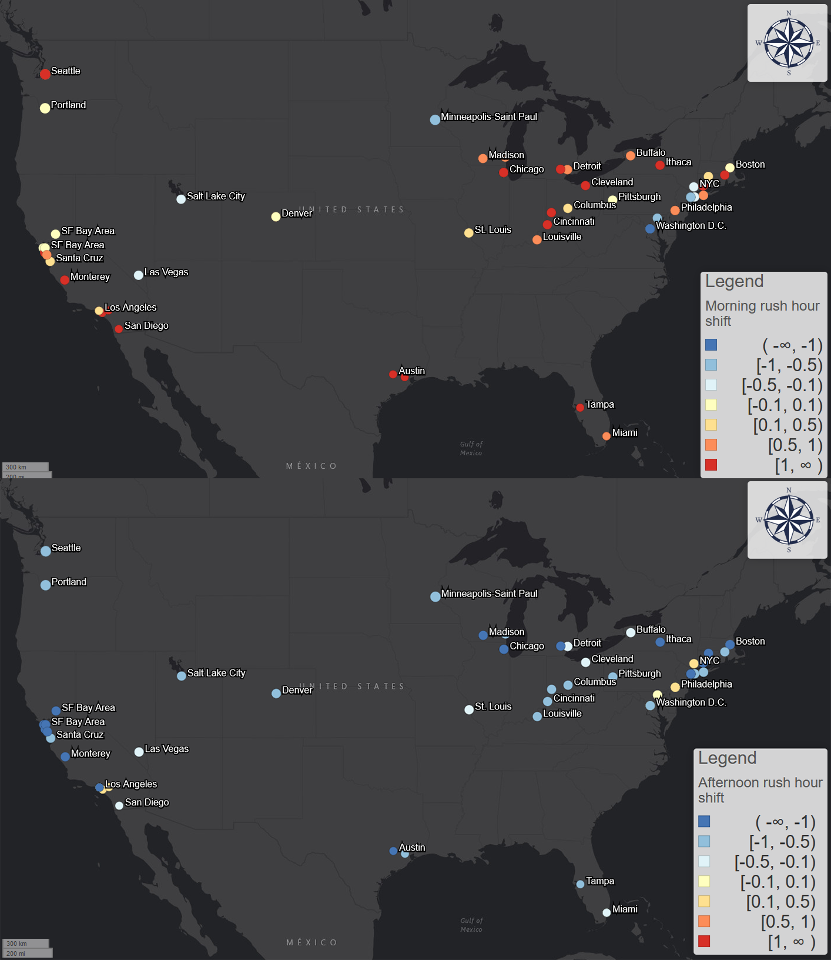

Figure 10: afternoon rush hour shift for different cities for all weekdays

Moreover, considering the shift of the morning and afternoon peak, the working hours would also change accordingly. Supposing that the change of working hours is the difference between the morning and afternoon peak shift, the average working hours of the United States shrank by 0.5 hours. Similarly, Australia’s working hours decreased by -1.45 hours and New Zealand’s decreased by -1.53 hours; while UK’s working hours increased by 1.25 hours, Canada’s increased by 0.65 hours, and France’s increased by 0.03 hours. Figure 11 visualizes the very polarized geographic pattern for working hours shift. The definite majority of the cities have a shorter working hours, which can be due to economic recession brought by the quarantine. However, New York, Washington D.C., and Baltimore have a longer working hour. This could be relevant to the nature of the local occupation composition whose essential workers’ working hour can be longer than the normal; or could also be because of the prolonged working hours for the medical workers during the pandemic in the epicenters like New York (36).

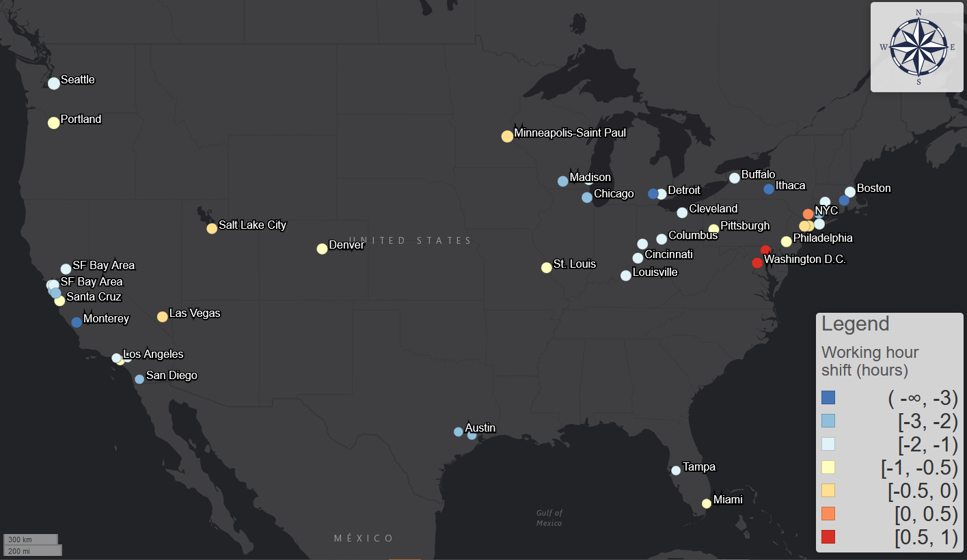

Figure 11: the shift of working hour.

1. Conclusion

In this paper, we use smartphone app activity data to measure transit demand for 113 transit systems across the United States; We use logistic model to fit the daily changing trends of each transit system’s usage and introduce three important parameters to measure the three dimensions of the transit decline due to COVID-19: extent, start/end date, and speed of the decline.

The minimum value of the transit demand curve, *floor value*, shows the ratio of “essential passengers” who continue to use transit system regardless of the pandemic. Geographic patterns shows information industry dominating areas and university cities have lower floor value. Further linear regression with floor value and different social-economic and demographic factors shows that: cities with less non-physical occupations ratio generally have higher floor value; cities with larger ratio of minority population (African American, Female, Hispanic) tends to have higher floor value; cities with more middle-age and senior people over 45 years old tends to have higher floor value; and last, cities with lower “Coronavirus” relevant search trend index tend to have higher floor value. These conclusions are also supported by the user demographic survey results conducted by Transit app. These conclusions all affirm an alarming and gloomy fact: **cities with more essential workers and more vulnerable population tends to maintain higher transit usage rate during the pandemic**. This moreover suggests the necessity of the transit system even during the COVID-19 period when transit systems lost their most ridership: people still need transit systems and essential workers need them especially. It is a good lesson for transit planners and policy makers to rethink the role of transit systems not as a business, but as a social warfare to protect and serve the most urgent and the most vulnerable.

The start and end date of transit demand curve, *divergent point* and *convergent point*, shows when the people started and finished acting to avoid transit trips due to COVID-19. We moreover compare divergent/convergent point with the first day of local community spread and the results shows that people’s response time is not synchronized with the development of the disease. If not considering incubation period, 54% of all transit systems’ passengers can start to react to the pandemic. If considering the reported median incubation period of 5 days, the number drops to 24%; and if using the reported maximum incubation period of 14 days, the number moreover drops to 5%. Meanwhile, if comparing the convergent point with the first day of local community spread, almost no transit systems can act faster to escape most exposure to the spreading pandemic. This suggests that the reacting speed of the transit systems is much slower than the ideal scenario that most passengers can already avoid transit trips before the community spread started.

The speed of the decline, *decay rate and decay duration*, shows how fast and how long the decline process lasted. The correlation reveals that the later the decline happened, the faster the process would be. This could be because of growing awareness thus fear as time passed to make people to act faster.

The commuting analyses based on hourly transit demand data show that active essential passengers’ commuting routine during the pandemic is very different from the normal routine. We used ordinary Procrustes analysis to measure these differences between hourly curves in two dimensions: the impact on the hourly curves’ shape, measured by Procrustes distance, and the average decrease amount, measured by stretch factor. The pattern of Procrustes distance is geographically polarized and highly correlated with the floor value: information industries dominating areas and university cities shows significantly larger change during the pandemic. The impact on hourly curves’ shape was increasing as the pandemic developed. The pandemic also made the weekdays and weekends less different. Weekdays are more like weekends because disproportional decrease of the morning and afternoon commuting activities made the difference between rush hours and normal hours less obvious; meanwhile weekdays are more like weekends in some places like New York because the cessation of unessential businesses made the weekends trips become commuting-dominating.

Moreover, the pandemic shifted the morning and afternoon rush hours. Morning rush hour shifted in two directions but the afternoon rush hour shifted later for 1 hour in average. The interval between two rush hours generally became shorter, which could indicate the significant recession of the economy activities during the pandemic. However, in cities like the epicenter of New York, the interval between two rush hours became longer, which can be because of prolonged working hours of medical workers and essential workers.

The paper is a good start to investigate the impact of COVID-19 on transit systems across the United States and the world. However, there are still several limitations that we did or cannot cover in this paper:

* **Representativeness of the transit demand data for actual ridership.** Although we provided a bias test between some official ridership data and the transit demand data and the results show highly relevance, correlation, and the unbiasedness of the dataset, we still cannot argue that transit demand measures are exactly the same as the official ridership data for each day and each system. In the future, it would be better to use the official ridership data to measure the exact impact on the ridership.
* **Missing hourly systems.** In the hourly data, there are several missing transit systems especially in the Deep South, such as Atlanta.
* **The homogenizing of different cities.** The minimum resolution of the data is each system and its corresponding county-equivalent. This can be too vague for system-level analysis. To see more about how the pandemic impacted the local transit system, future studies could use surveys, local transit ridership data, and surveillance data with higher resolutions to detect more detailed patterns.

Reference:

1. Weber H. Air traffic data shows less crowded skies since the coronavirus spread [Internet]. 2020 [cited 2020 Apr 2]. Available from: https://www.fastcompany.com/90485186/its-time-to-cancel-rent

2. Yellin J. North Americans Turning Away From Public Transit As Direct Result Of COVID-19 [Internet]. 2020 [cited 2020 Feb 4]. Available from: https://www.northstarhub.com/posts/north-americans-turning-away-from-public-transit-as-direct-result-of-covid-19

3. WMATA. Metro and Covid-19: Steps we’ve taken [Internet]. 2020 [cited 2020 Apr 2]. Available from: https://www.wmata.com/service/status/details/COVID-19.cfm

4. Christensen K. COVID-19 drives down ridership as El Dorado Transit adapts [Internet]. 2020 [cited 2020 Feb 4]. Available from: https://www.mtdemocrat.com/news/covid-19-drives-down-ridership-as-el-dorado-transit-adapts/

5. Wang K-Y. How change of public transportation usage reveals fear of the SARS virus in a city. PLoS One. 2014;9(3).

6. Kim C, Cheon SH, Choi K, Joh C-H, Lee H-J. Exposure to fear: Changes in travel behavior during MERS outbreak in Seoul. KSCE J Civ Eng. 2017;21(7):2888–95.

7. Transit app. Transit • Bus & Subway Times [Internet]. 2020 [cited 2020 Feb 4]. Available from: https://play.google.com/store/apps/details?id=com.thetransitapp.droid&hl=en_US

8. Transit app. How coronavirus is disrupting public transit [Internet]. 2020. Available from: https://transitapp.com/coronavirus#monitor

9. Biocomplexity Institute U of V. COVID-19 Surveillance Dashboard [Internet]. 2020. Available from: https://nssac.bii.virginia.edu/covid-19/dashboard/

10. JHU CSSE. 2019 Novel Coronavirus COVID-19 (2019-nCoV) Data Repository by Johns Hopkins CSSE [Internet]. 2020. Available from: https://github.com/CSSEGISandData/COVID-19/

11. USAFacts. Coronavirus Locations: COVID-19 Map by County and State [Internet]. 2020. Available from: https://usafacts.org/visualizations/coronavirus-covid-19-spread-map/

12. U.S. Bureau of Labor Statistics. Table 1. Workers who could work at home, did work at home, and were paid for work at home, by selected characteristics, averages for the period 2017-2018 [Internet]. 2019 [cited 2020 May 16]. Available from: https://www.bls.gov/news.release/flex2.t01.htm

13. Tan S, Fowers A, And DK, Tierney L. Amid the pandemic, public transit is highlighting inequalities in cities [Internet]. Washington Post. 2020 [cited 2020 May 16]. Available from: https://www.washingtonpost.com/nation/2020/05/15/amid-pandemic-public-transit-is-highlighting-inequalities-cities/?arc404=true

14. Cooke TJ. Geographic access to job opportunities and labor-force participation among women and African Americans in the greater Boston metropolitan area. Urban Geogr. 1997;18(3):213–27.

15. Golub A, Marcantonio RA, Sanchez TW. Race, space, and struggles for mobility: transportation impacts on African Americans in Oakland and the East Bay. Urban Geogr. 2013;34(5):699–728.

16. Iseki H, Taylor BD. The demographics of public transit subsidies: a case study of Los Angeles. 2010;

17. Centers for Disease Control and Prevention. Coronavirus 2019 (COVID-19) Surveillance [Internet]. 2020. Available from: https://www.cdc.gov/nchs/nvss/vsrr/covid19/index.htm

18. Lin Y-H, Liu C-H, Chiu Y-C. Google searches for the keywords of “wash hands” predict the speed of national spread of COVID-19 outbreak among 21 countries. Brain Behav Immun. 2020;

19. Li C, Chen LJ, Chen X, Zhang M, Pang CP, Chen H. Retrospective analysis of the possibility of predicting the COVID-19 outbreak from Internet searches and social media data, China, 2020. Eurosurveillance. 2020;25(10):2000199.

20. Yuan GX, Di L, Gu Y, Qian G, Qian X. The Prediction for the Outbreak of COVID-19 for 15 States in USA by Using Turning Phase Concepts as of April 10, 2020. Available SSRN 3575002. 2020;

21. Google. Google Trends - COVID19 [Internet]. 2020 [cited 2020 Dec 5]. Available from: https://trends.google.com/trends/explore?date=today 3-m&geo=US&q=COVID19

22. Spatial.ai. COVID-19 Social Media Counts & Sentiment [Internet]. 2020 [cited 2020 Apr 21]. Available from: https://www.arcgis.com/home/item.html?id=feb6280d42de4e91b47cf37344a91eae#overview

23. Transit app. Who’s left riding public transit? Hint: it’s not white people. [Internet]. 2020. Available from: https://medium.com/transit-app/whos-left-riding-public-transit-hint-it-s-not-white-people-d43695b3974a

24. Transit app. Who’s Onboard? Surveying Transit Riders During the Coronavirus Pandemic [Internet]. 2020. Available from: https://www.youtube.com/watch?v=qkT9XQtd1o4

25. Lauer SA, Grantz KH, Bi Q, Jones FK, Zheng Q, Meredith HR, et al. The incubation period of coronavirus disease 2019 (COVID-19) from publicly reported confirmed cases: estimation and application. Ann Intern Med. 2020;

26. Cheng H-Y, Jian S-W, Liu D-P, Ng T-C, Huang W-T, Lin H-H. High transmissibility of COVID-19 near symptom onset. medRxiv. 2020;

27. Pan X, Chen D, Xia Y, Wu X, Li T, Ou X, et al. Asymptomatic cases in a family cluster with SARS-CoV-2 infection. Lancet Infect Dis. 2020;20(4):410–1.

28. Dong Y, Mo X, Hu Y, Qi X, Jiang F, Jiang Z, et al. Epidemiological characteristics of 2143 pediatric patients with 2019 coronavirus disease in China. Pediatrics. 2020;

29. Achenbach J, Mettler K, Sun LH, Guarino B. Coronavirus may have spread undetected for weeks in Washington state, which reported first two deaths in U.S. [Internet]. Washington Post. 2020 [cited 2020 Mar 4]. Available from: https://www.washingtonpost.com/health/coronavirus-may-have-spread-undetected-for-weeks-in-washington-state/2020/03/01/0f292336-5bcc-11ea-9055-5fa12981bbbf_story.html

30. Popovich N. How U.S. Coronavirus Diagnoses Are Lagging Behind the Outbreak [Internet]. 2020 [cited 2020 Mar 4]. Available from: https://www.nytimes.com/interactive/2020/04/01/us/coronavirus-covid-19-symptoms-data.html

31. Mitteroecker P, Gunz P, Windhager S, Schaefer K. A brief review of shape, form, and allometry in geometric morphometrics, with applications to human facial morphology. Hystrix, Ital J Mammal. 2013;24(1):59–66.

32. U.S. Bureau of Labor Statistics. Labor force characteristics by race and ethnicity, 2018 [Internet]. 2018. Available from: https://www.bls.gov/opub/reports/race-and-ethnicity/2018/home.htm

33. McLauphlin EC. CDC official warns Americans it’s not a question of if coronavirus will spread, but when [Internet]. 2020 [cited 2020 Feb 4]. Available from: https://www.cnn.com/2020/02/25/health/coronavirus-us-american-cases/index.html

34. Glanz J, Carey B, Holder J, Watkins D, Valentino-DeVries J, Rojas R, et al. Where America Didn’t Stay Home Even as the Virus Spread [Internet]. The New York Times. 2020 [cited 2020 Apr 4]. Available from: https://www.nytimes.com/interactive/2020/04/02/us/coronavirus-social-distancing.html?referringSource=articleShare

35. Evans E. City, county leaders declare local state of disaster due to coronavirus concerns [Internet]. 2020 [cited 2020 Apr 4]. Available from: https://www.fox7austin.com/news/city-county-leaders-declare-local-state-of-disaster-due-to-coronavirus-concerns

36. Noguchi Y. Trauma On The Pandemic’s Front Line Leaves Health Workers Reeling [Internet]. 2020 [cited 2020 May 16]. Available from: https://www.npr.org/sections/health-shots/2020/04/23/840986735/trauma-on-the-pandemics-front-line-leaves-health-workers-reeling